Lecture: 1.3.1: Basic operations: AND (^), OR (˅)
Course outcome to be covered:
CO1: Apply and recognized about the Logics

Propositional Logic
Propositional Logic is concerned with statements to which the truth values, “true” and “false”, can be assigned. The purpose is to analyze these statements either individually or in a composite manner.
A proposition is a collection of declarative statements that has either a truth value "true” or a truth value "false". A propositional consists of propositional variables and connectives. We denote the propositional variables by capital letters (A, B, etc). The connectives connect the propositional variables.
Some examples of Propositions are given below −
- "Man is Mortal", it returns truth value “TRUE”
- "12 + 9 = 3 – 2", it returns truth value “FALSE”
The following is not a Proposition −
- "A is less than 2". It is because unless we give a specific value of A, we cannot say whether the statement is true or false.
Connectives
In propositional logic generally we use five connectives which are −
- OR (∨)
- AND (∧)
- Negation/ NOT (¬)
- Implication / if-then (→)
- If and only if (⇔)
OR (∨) − The OR operation of two propositions A and B (written as A∨B) is true if at least any of the propositional variable A or B is true.
The truth table is as follows −

A | B | A ∨ B
True | True | True
True | False | True
False | True | True
False | False | False

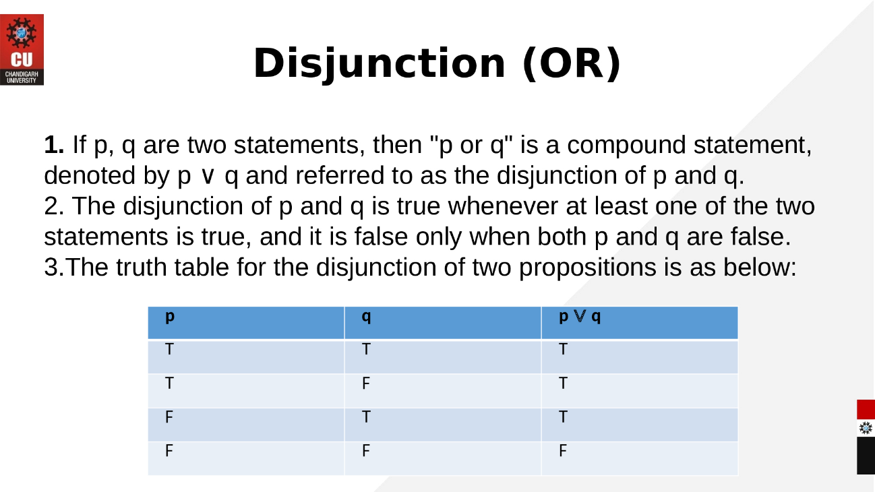

AND (∧) − The AND operation of two propositions A and B (written as A∧B) is true if both the propositional variable A and B is true.
The truth table is as follows −
A | B | A ∧ B
True | True | True
True | False | False
False | True | False
False | False | False
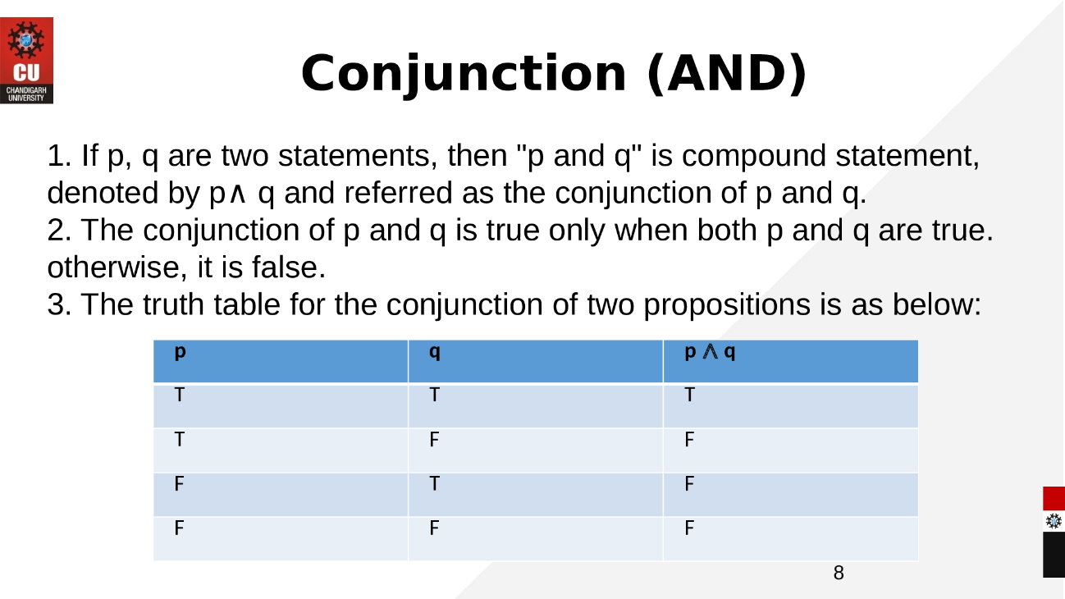

Links: https://www.youtube.com/watch?v=P4LyRvlSAUY
eBook Discrete Mathematics
https://old.amu.ac.in/emp/studym/99998829.pdf

